Cell Stem Cell Guide:

The Summary is a single paragraph no longer than 150 words. An effective Summary includes the following elements: (1) a brief background of the question that avoids statements about how a process is not well understood; (2) a description of the results and approaches/model systems framed in the context of their conceptual interest; and (3) an indication of the broader significance of the work. We discourage novelty claims (e.g., use of the word “novel”) because they are overused, tend not to add meaning, and are difficult to verify. Please do not include references in the Summary.

**Title: Culture associated global DNA Methylation changes in Human Intestinal Epithelial Organoids**

Organoids are a powerful tool to model major aspects of development, health and disease. A necessary aspect of organoid models is the expansion of cultures *in-vitro* through several rounds of passaging. This is of potential concern as high passaging of cell cultures has been shown to effect cellular function. We have generated genome wide DNA methylation (DNAm) profiles from 80 human intestinal organoids derived from small and large bowel mucosal biopsies. Our analyses revealed a major effect of passage on DNAm leading to significant changes at 61,337 CpGs. High passage organoids were found to be globally hypomethylated and locally hypermethylated, with greater variability in DNAm with increasing passage. Importantly, we were able to validate the observed passage effect in an additional 76 publicly available organoids, including healthy gut organoids as well as cultures generated from several malignant tissues including pancreas, rectum, stomach, and lung organoids. Together, our findings suggest a major impact of prolonged *in-vitro* culturing on global organoid DNA methylation profiles thereby highlighting the importance of considering passage as an important variable in organoid related experiments.

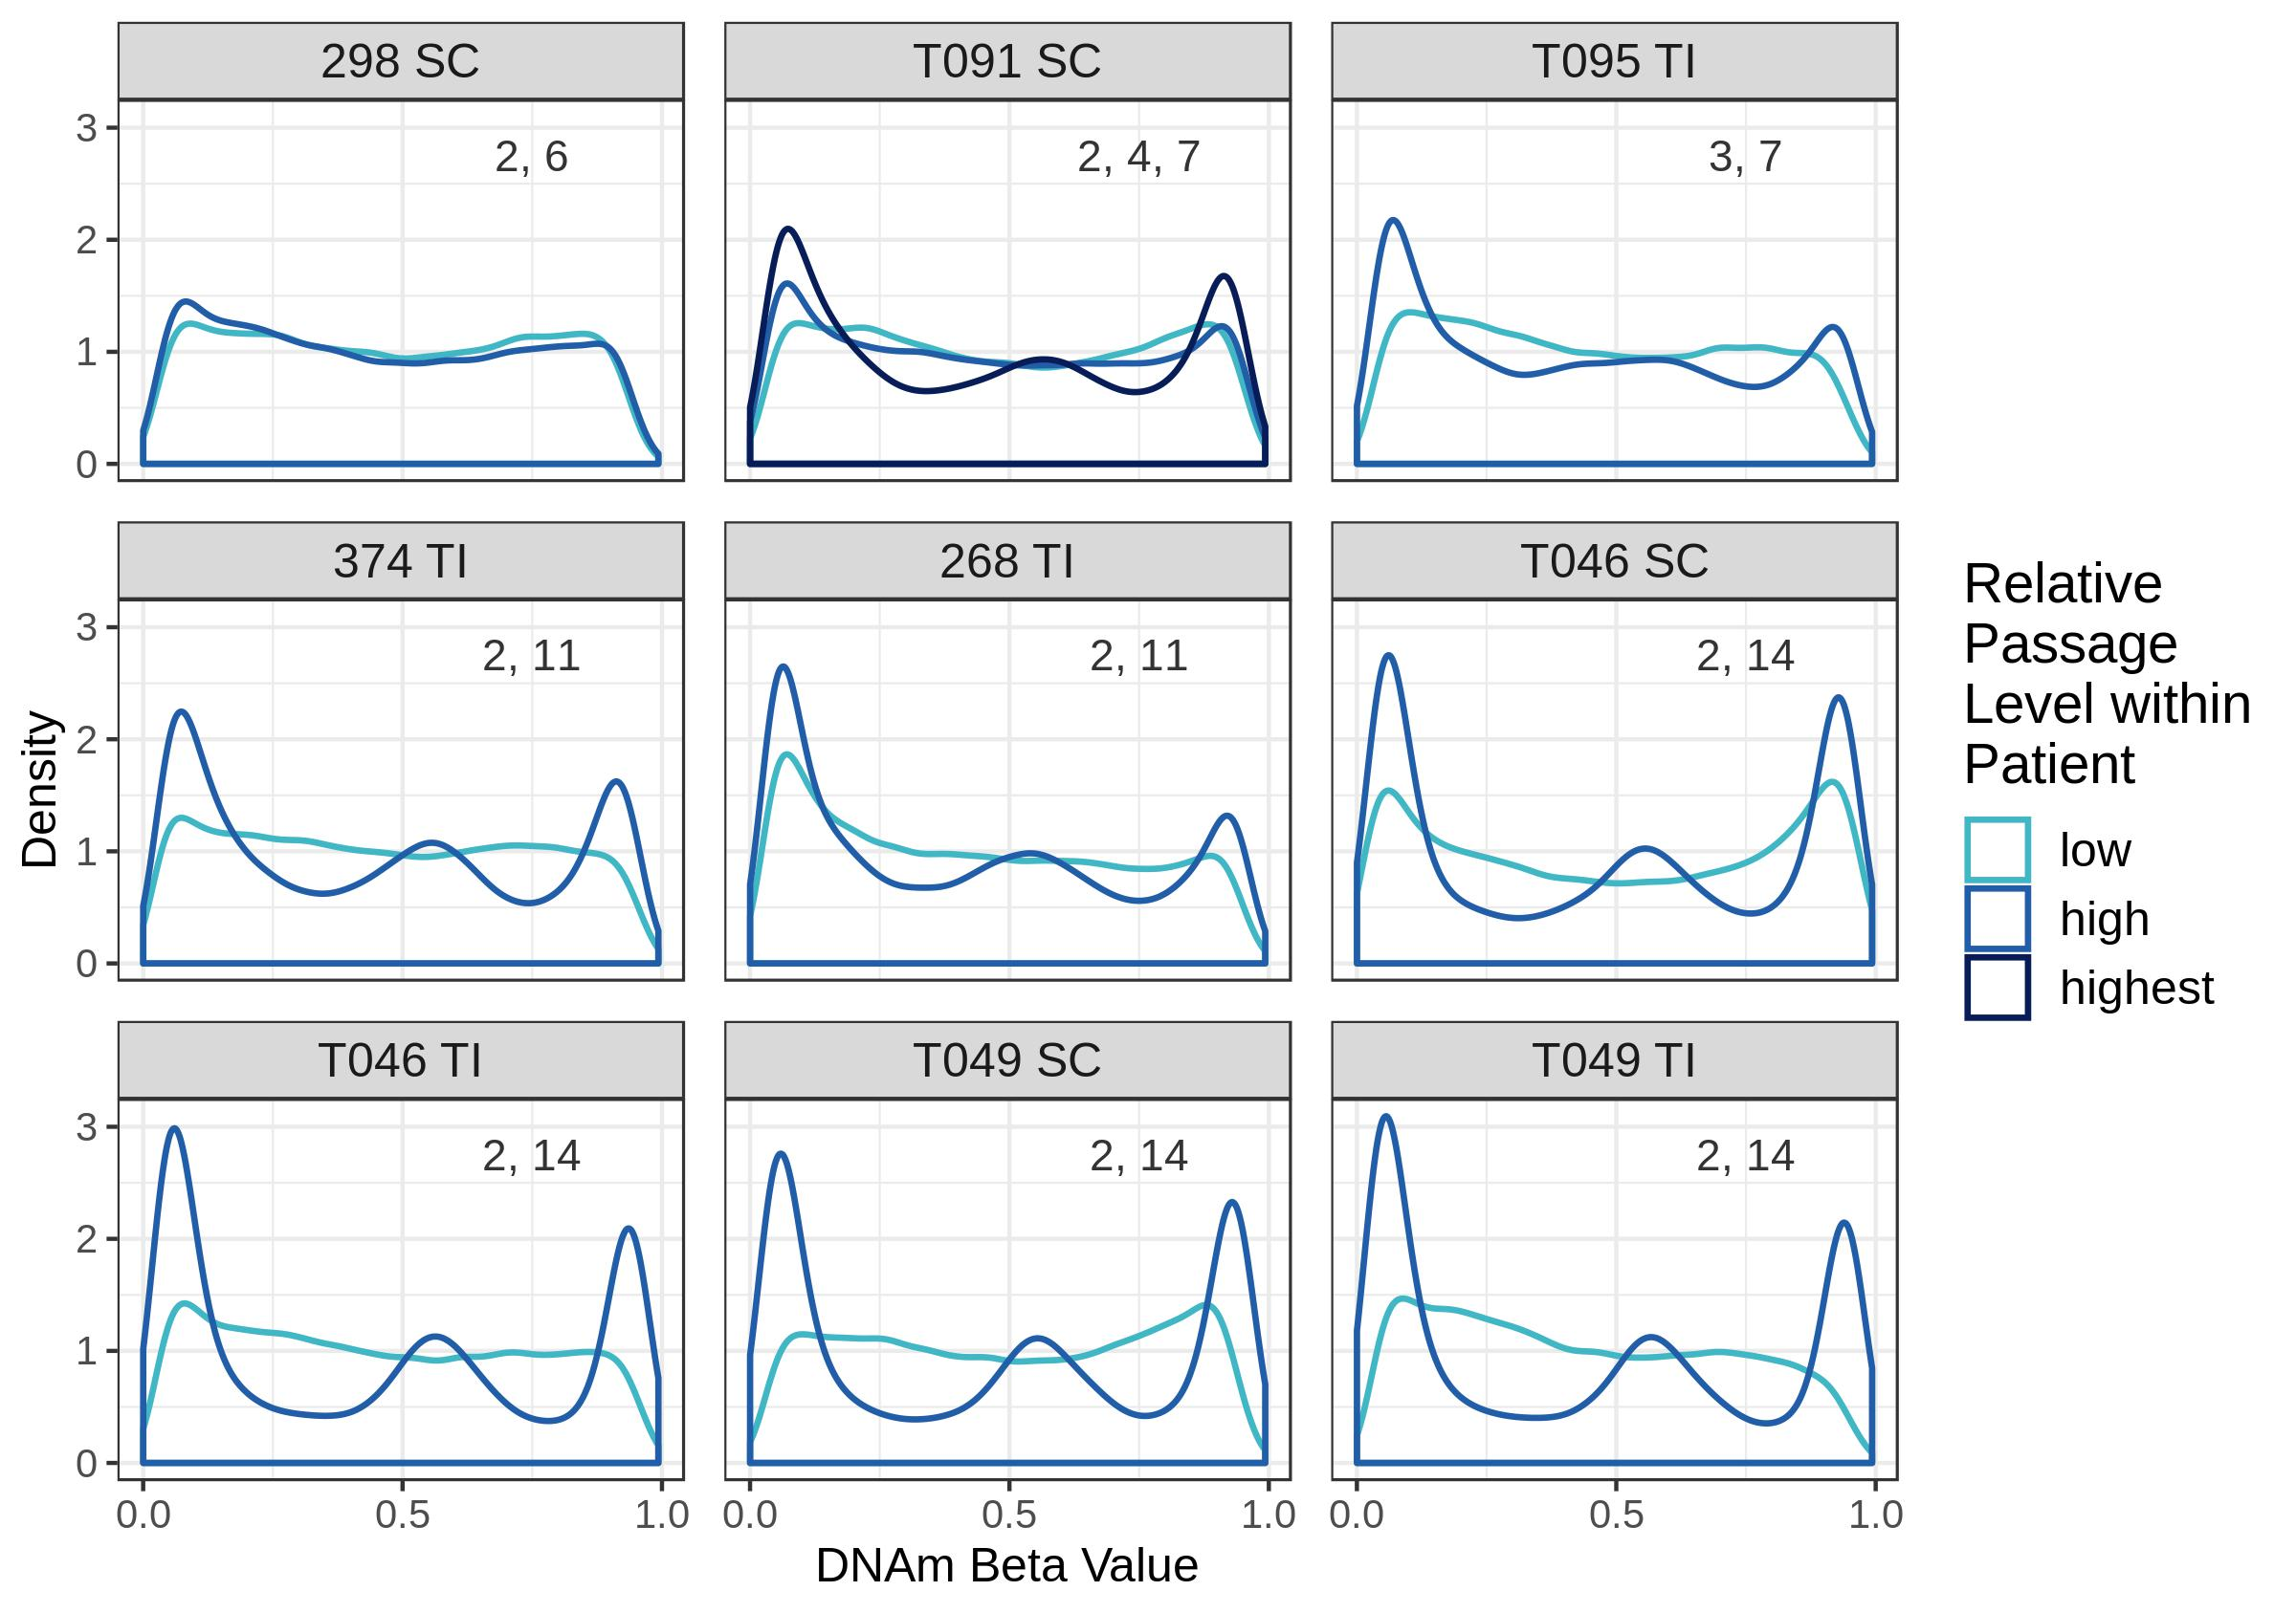

**Figure 1. DNAm beta value distributions are trimodal for high passage samples but bimodal for low passage samples, even within an individual.** DNAm beta value distributions for samples derived from the same patient but cultured to a different number of passages. Distributions displayed are for the 51,545 most variable CpGs. Plots are labelled with the patient ID number, sampling site of origin (TI:terminal ileum, SC:sigmoid colon) and the passage number of each organoid derived from that patient and sampling site. Curves are coloured by high or low passage relative to the other sample(s).